
Caribbean Community Secretariat
P.O. Box 10827
Turkeyen
Greater Georgetown

Guyana

Your Ref:

Our Ref: EuropeAid/137491/1H/SUP/Multi

Responses to Request for Clarification

- Question: Usually if the value of the offer is less than EUR 100,000 the origin of the goods is open to all countries. This specification is not written in the tender dossier and not even in the special conditions. Do we have to consider the origin open to any country if our offer is below EUR 100,000?

Answer: All goods purchased under the contract must originate in a Member State of the European Union or in a country or territory of the regions covered and/or authorised by the specific instruments applicable to the programme specified in clause 3.1of the Instructions to Tenderers.

- Question: LOT 2 ITEM 2: Please specify which STATA software you are demanding among STATA/IC 14, STATA/SE 14 and STATA MP 14 (2‐Cores)

Answer: STATA/IC 14

- Question: LOT 3 ITEMS 1 AND 2: to allow a fair competition among the brands would it be possible to provide 2 x 512 GB SSD for a total of 1024 GB (a bit more than 1TB) rather than a unique SSD with 1TB ?

Answer: It is ok to provide 2 x 512 GB SSD for a total of 1024 GB

- Question: LOT 3 ITEM 6: the « 120V » you ask for is referred to the input voltage or the output voltage? Considering that UPSs must be sent to all the 3 countries that support 115V (Trinidad), 240V(Saint Lucia) and 110V (Jamaica) is it possible to offer a UPS with a voltage range of 110‐240V?

Answer: Reference is to the input voltage. St Lucia uses 220. The bulk of the ups will be in Trinidad and Tobago we would prefer if these are the standard 115V. The ones for Jamaica and St Lucia can be with a voltage range of 110‐240V? (Please see pictures of wall outlets below)

- Question: LOT 4 ITEM 1: you write both « 8 x 10/100/1000 Gigabit Ethernet » and « POE‐24 ». Are you requesting an 8‐port switch or a 24‐port switch?
Answer: 24‐port switches is required

Trinidad and Tobago
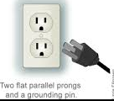

St Lucia
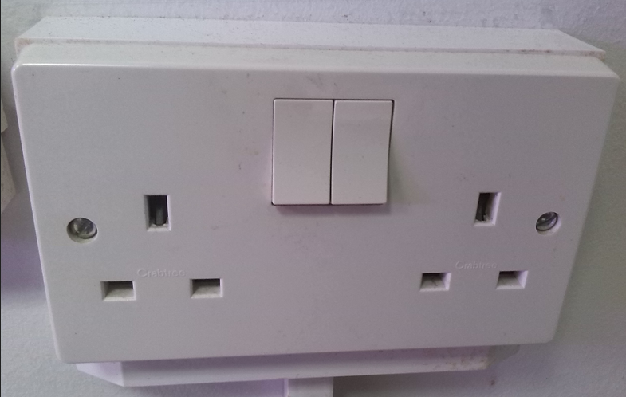

Jamaica

